

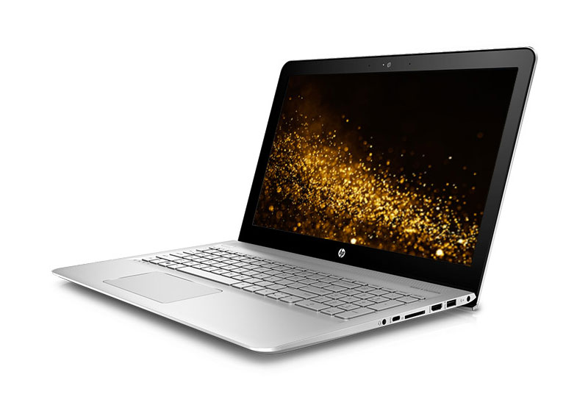

Brand Name:

HP

Product Name:

Laptop Ebook:E29678

About:

HP since its advent has offered complete solutions to their customers. Not only these solutions were far ahead than what could the competition could offer but also relatively affordable as compared to the competition`s offering.

Specifications:

|  |  |
| --- | --- |
| **Processor Type** | Intel Celeron Dual Core N3050 (2 MB Cache) |
| **Processor Speed** | 2.16 GHz Up to 2.48 GHz, 2 MB cache, 2 Cores, 2 Threads |
| **Installed RAM** | 02 GB DDR3 |
| **Type of memory** | On-board DDR3L SDRAM |
| **Hard drive size** | 32GB eMMC |
| **Hard drive speed** | - |
| **Optical Drive** | No |
| **Type of optical drive** | - |
| **SSD** | None |
| **Type of harddrive** | eMMC |
| **Internal/External** | External (Optional) |
| **Card Reader** | Yes |
| **Type of memory cards** | Multi-Format Digital Media Card Reader |
| **Dedicated graphics** | No |
| **Graphics memory** | Intel |
| **Type of graphics memory** | Shared |
| **Switchable graphics** | No |
| **Graphics processor** | Intel |
| **Maximum shared graphics** | - |
| **Aspect ratio** | 16:9 |
| **Backlight** | LED |
| **Screen size** | 11.6" diagonal HD anti-glare WLED-backlit |
| **Screen surface** | Diagonal HD anti-glare WLED-backlit |
| **Screen resolution** | 1366x768 |
| **Touchscreen** | No |
| **Condition** | Refurbished |
| **Colors** | No |
| **Color** | Blue |
| **Dimensions (WxHxD)** | 11.81 in (W) x 8.1 in (D) x 0.72 in (H) |
| **Weight** | 2.6 LB |
| **Fingerprint Reader** | No |
| **Numeric keyboard** | No |
| **Backlit keyboard** | No |
| **3G** | No |
| **EDGE** | No |
| **Bluetooth** | Yes |
| **Type of bluetooth** | Bluetooth 4.0 |
| **LAN** | Yes |
| **Speed** | 1 RJ-45 (LAN) |
| **Modem** | No |
| **Wireless/Wifi** | Yes |
| **Type** | 802.11b/g/n WLAN |
| **Infrared** | No |
| **DVI out** | No |
| **USB** | Yes |
| **USB 2.0** | 2 Universal Serial Bus (USB) 2.0 |
| **USB 3.0** | 1 SuperSpeed USB 3.0 |
| **USB Ports (Total)** | 3 |
| **TV-out** | No |
| **Serial port** | No |
| **S/PDIF out** | No |
| **Parallel port** | No |
| **Microphone input** | 1 Headphone-out/microphone-in combo jack |
| **Headphone output** | 1 Headphone-out/microphone-in combo jack |
| **Firewire** | No |
| **eSATA** | No |